Commutative Property - Definition | Commutative Law and Examples
The Commutative property is a basic math rule that helps make calculations easier. It states that the result of an operation between two numbers remains the same irrespective of the position of the numbers. For example, 2 + 3 is the same as 3 + 2, and 4 × 5 is the same as 5 × 4.
It is an important property of mathematics. Which is satisfied by the addition(+) and multiplication(×) operations.
In this article, we will explore the commutative property, its definition, and examples, in detail.
What is Commutative Property?
Commutative Property is the property according to which the sequence of two operands does not change the result. In commutative property the switching of the operands does not affect the result of the given expression.
The commutative property is the property in which the order of the two operands does not affect the result of the expression. The commutative word is derived from the word commute which means switching. The arithmetic operator addition and multiplication satisfies the commutative property.
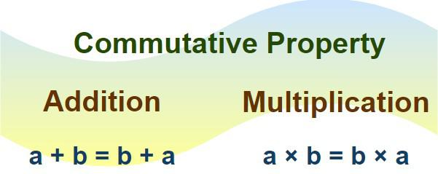Commutative Property Definition
Examples,
- 4 + 7 = 7 + 4 = 11
- 5 + 4 = 4 + 5 = 9
- 4 × 7 = 7 × 4 = 28
- 5 × 4 = 4 × 5 = 20
Commutative Property Formula
Commutative property is satisfied by the addition and multiplication arithmetic operators only. For two numbers P and Q, the commutative property formula is given by:
- P + Q = Q + P
- P × Q = Q × P
Commutative Property of Addition
According to the Commutative property for addition the order of two operands related with addition operator does not affects the result of addition.
Commutative Property for Addition Formula
For addition of two numbers X and Y, the commutative property for addition formula is given below:
X + Y = Y + X
Commutative Property of Addition Examples
Following are some examples for the commutative property for addition:
- 4 + 9 = 9 + 4
- (-12) + 5 = 5 + (-12)
- 8/9 + 1/3 = 1/3 + 8 / 9
Commutative Property of Multiplication
The commutative property for multiplication states that the order of two operands related with multiplication operator has no affect in the result of multiplication.
Commutative Property for Multiplication Formula
For multiplication of two numbers X and Y, the commutative property for addition formula is given below:
X × Y = Y × X
Commutative Property of Multiplication Examples
Following are some examples for the commutative property for addition:
- 4 × 9 = 9 × 4
- (-12) × 5 = 5 × (-12)
- (8 / 9) × (1 /3) = (1 / 3) × (8 / 9)
Non-Commutative Operations - Division And Subtraction
Non-Commutative operations refers to those operations that do not follow the commutative property and changing the order of the numbers in the operations changes the result of the operation. The arithmetic operators subtraction and division does not satisfy the commutative property as changing the order of the operands changes the result of the expression, and this can be explained by the given examples.
For two operands R and S,
- R - S ≠ S - R
- R / S ≠ S / R
Example 1: Suppose we take two numbers 12 and 3 then dividing 12 by 3 and dividing 3 by 12 gives the separate results, i.e.
- 12/3 = 4
- 3/12 = 1/4
Example 2: Let's take two numbers 15 and 35 then subtracting 15 from 35 and subtracting 35 from 15 gives the separate results, i.e.
- 35 - 15 = 20
- 15 - 35 = -20
Commutative Property vs Associative Property
The differences between commutative property and associative property is explained in the table below,
Commutative Property | Associative Property
Commutative property states that the order of the number in some operations(such as multiplication and addition) dose not effects the results of the operation. | Associative property states that grouping various number in different operations (such as multiplication and addition) does not changes the result of the operation.
Commutative Formula:  - A + B = B + A  - A × B = B × A | Associative Formula:  - A + (B + C) = (A + B) + C = (A + C) + B  - A × (B × C) = (A × B) × C = (A × C) × B
Example: 4 + 5 = 5 + 4 = 9 | Example: (3 + 4) + 5 = 3 + (4 + 5) = 12
Read More,
- Properties of Rational Numbers
- Properties of Real Numbers
- Properties of Integers
Solved Examples on Commutative Property
Example 1: Which of the following satisfies the commutative property:
(i) 4 × 5
(ii) 7 + 8
(iii) 9 / 2
(iv) 15 - 6
Solution:
- 4 × 5
4 × 5 = 20
5 × 4 = 20
Commutative Property Satisfies
- 7 + 8
7 + 8 = 15
8 + 7 = 15
Commutative Property Satisfies
- 8 / 2
8 / 2 = 4
2 / 8 = 1 / 4
4 ≠ 1/4
Commutative Property Does Not Satisfies
- 15 - 6
15 - 6 = 9
6 - 15 = -9
9 ≠ -9
Commutative Property Does Not Satisfies
Example 2: Prove that p + q = q + p if p = 9 and q = 7.
Solution:
p + q = 9 + 7 = 16
q + p = 7 + 9 = 16
p + q = q + p
Hence proved
Example 3: Prove that p × q = q × p if p = 10 and q = 3.
Solution:
p × q = 10 × 3 = 30
q × p = 3 × 10 = 30
p × q = q × p
Hence Proved
Practice Problems On Commutative Property
Problem 1: Which of Following Satisfies Commutative Property
42 × 15
12 + 7
23 / 3
25 - 8
Problem 2: Prove x + y = y + x if x = 10 and y = 17
Problem 3: Prove x × y = y × x if x = 2 and y = 23
Problem 4: Apply the commutative property of addition to rearrange and simplify the expression : 3a + 4b + 2a + 5b.
Conclusion
The commutative property is a helpful math rule that makes adding and multiplying numbers easier. It means you can change the order of the numbers, and the answer will stay the same! For example, 2 + 3 is the same as 3 + 2, and the same rule applies for multiplication 5 × 6 = 6 × 5. But remember, this doesn’t work for subtraction or division. Knowing this property is super useful when solving math problems and makes math feel a lot less tricky
Commutative Property-FAQs
What is Commutative Property in Math?
Commutative property in Math is the property in which the switching of the two operands does not change the result of the expression.
What is Commutative Law for Multiplication?
Commutative property of multiplication states that the change in position of the two operands for multiplication does not change the result.
A × B = B × A
What is Commutative Law for Addition?
Commutative property of addition states that the change in position of the two operands for addition does not change the result.
A + B = B + A
Can Commutative Property be used for Subtraction and Division?
No, the commutative property cannot be used for subtraction and division as these operators does not satisfy the commutative property.
What do you Mean by Commutative Laws?
Commutative laws include the commutative property for addition and commutative property of multiplication.
- A + B = B + A
- A × B = B × A
What is Commutative Property for Addition?
Commutative Property for Addition states that, adding two numbers the order of the numbers in addition is not important, i.e. a + b = b + a.
Division:
What is Division?
The division is the process of sharing a collection of items into equal parts and is one of the basic arithmetic operations in maths. We may face different situations every day where we use the division technique.
Division by Zero:
The division of any number by zero is undefined. In this case, the result can be written as infinity. For example, 15/0 = ∞, i.e. undefined.
Division Algorithm:
Division of any expression follows the division algorithm given below.
Dividend = Divisor × Quotient + Remainder
This algorithm helps in finding the missing numbers in the division problem.
Division Rule
Division rule involves four steps; they are:
Step 1: Identify the dividend and divisor and then write in the respective places.
Step 2: Multiply the divisor with a suitable number such that we get a result close to the dividend.
Step 3: Subtract the values in the dividend column.
Step 4: Now, bring down the result and repeat the preceding two steps until the remainder is less than the divisor.
This can be understood clearly with the help of the below figure:
Verification of Division Result:
It is easy to verify whether the obtained answer is accurate or incorrect in nature. The reverse process of multiplication is termed as division. The method to verify the answer using the given information is discussed below. Consider a simple example of 6 being divided by 2 gives 3. It can be mathematically written as
6 ÷ 2 = 3
Here the remainder is 0 as 6 completely divides 2 and the quotient is 3.
Dividend = (Divisor × Quotient) + Remainder
6 = (2 * 3) + 0
Division Sums
The process of division can be better understood with the help of the below sums. Here, different cases have been covered in the division of numbers.
1) What is the remainder from the division of 906 by 6?
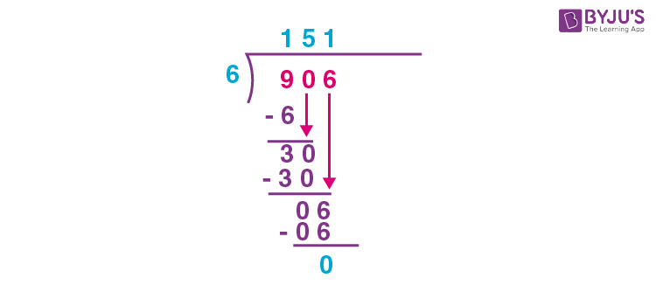
Here, remainder = 0
Quotient = 151
2) Complete the division: 8503 ÷ 18 = ______ + 7
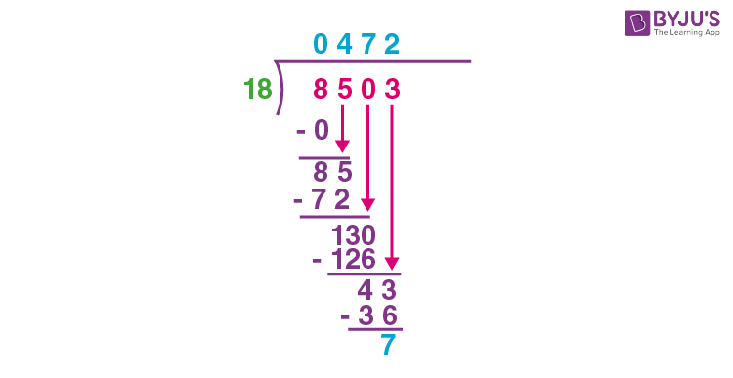
Therefore, 8503 ÷ 18 = 18 × 472 + 7
3) Write the quotient when 2037 is divided by 12.
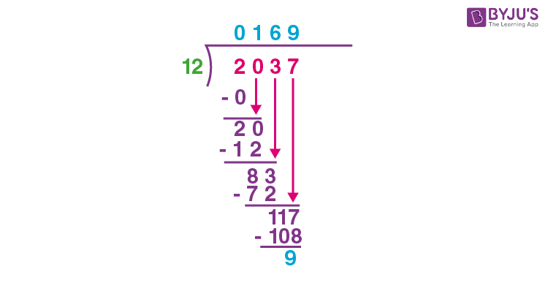
Therefore, the quotient is 169.
Click here to understand how to divide the numbers in detail.
Division 3 Digits
In this section, you will learn how to divide a 3 digit number and division of numbers by a 3 digit number.
1) Perform division for 483 with 7 as a divisor.
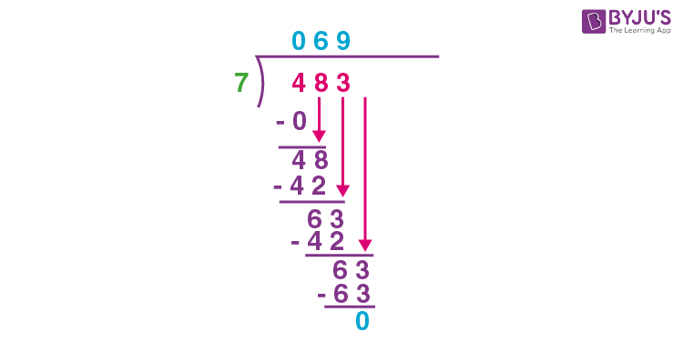
Now, let’s have a look at the division of a number by a three-digit number.
2) Compute: 580654 ÷ 112
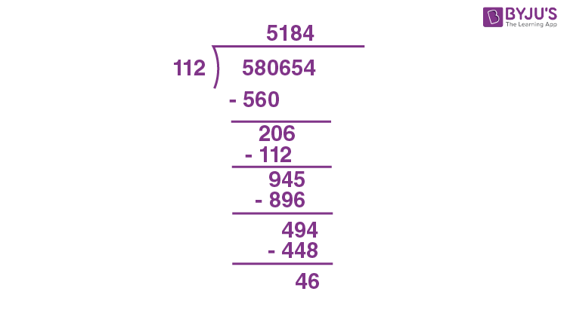
Division of Fractions
The division of fractions is quite different from the division of natural numbers. While dividing fractions, we have to convert the division operator to multiplication. That means the inverted divisor should be multiplied with the dividend. Let’s have a look at the below example.
Divide 12/5 by 16/3:
Numerator = 12/5
Denominator = 16/3
We can write the division of 12/5 by 16/3 as:
(12/5) ÷ (16/3)
= (12/5)/ (16/3)
Now, converting “÷” into “×” means that the divisor should be inverted and multiplied.
(12/5) × (3/16)
= (3/5) × (3/4)
= 9/20
Thus, the division 12/5 by 16/3 gives 9/20 as a result in fraction form.
Division Examples
Below are examples of division problems in maths.
Example 1:
What is the remainder when 6585 is divided by 13?
Solution:
From the given,
Dividend = 6585
Divisor = 13
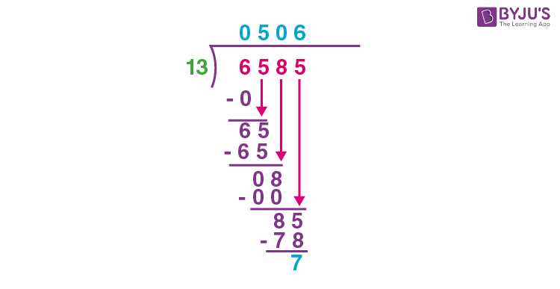
Therefore, the remainder is equal to 7.
Example 2:
Divide 1764 by 11.
Solution:
From the given,
Dividend = 1764
Divisor = 11
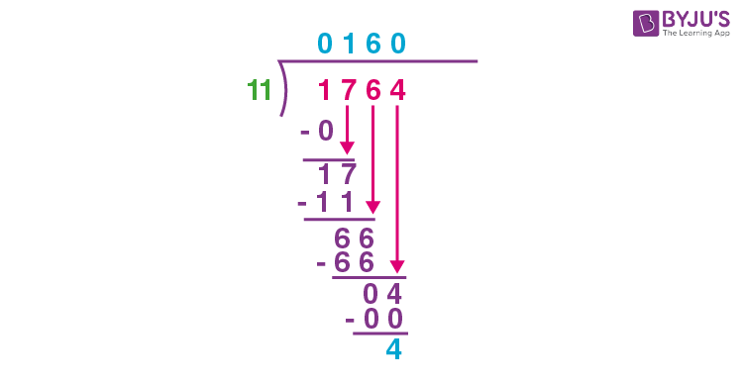
Therefore, the division of 1764 by 11 gives the quotient as 160 by leaving the remainder 4.
Practice Problems
- Find the quotient when 6556 is divided by 4.
- Divide 18187 by 137 and write the quotient and remainders.
- What is the remainder when 17080 is divided by 54?

Frequently Asked Questions on Division
Q1
What is division in maths?
In maths, a division is a process of splitting a specific amount into equal parts. For example, we can divide a group of 20 members into 4 groups of 5 members each or 5 groups of 4 members each, and so on.
Q2
What is the division algorithm formula?
The division algorithm formula is given as:
Dividend = Divisor × Quotient + Remainder
Q3
What is the remainder formula?
The formula of the remainder is:
Remainder = Dividend – (Divisor × Quotient)
Q4
What is the value of division by 0?
The division of any number by 0 gives infinity, i.e. the value of division by 0 is undefined.
Q5
What is the symbol of division?
The symbols used to denote the division are ÷, slash (/) or a horizontal line ( _ ).
What are Polygons?
A Polygon is a closed figure made up of line segments (not curves) in a two-dimensional plane. Polygon is the combination of two words, i.e. poly (means many) and gon (means sides).
A minimum of three line segments is required to connect end to end, to make a closed figure. Thus a polygon with a minimum of three sides is known as Triangle and it is also called 3-gon. An n-sided polygon is called n-gon.
Polygon shape
By definition, we know that the polygon is made up of line segments. Below are the shapes of some polygons that are enclosed by the different number of line segments.
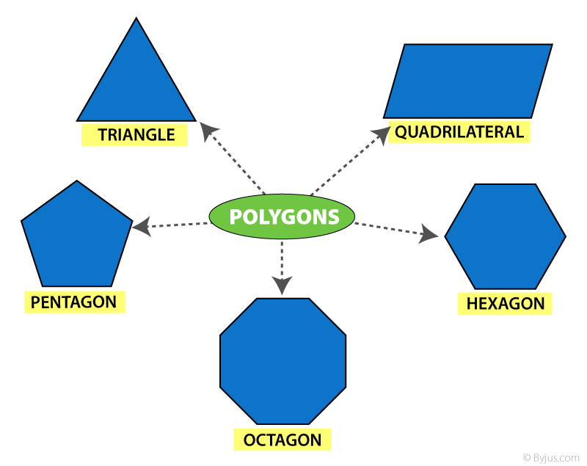
Types of Polygon
Depending on the sides and angles, the polygons are classified into different types, namely:
- Regular Polygon
- Irregular Polygon
- Convex Polygon
- Concave polygon
Regular Polygon
If all the sides and interior angles of the polygon are equal, then it is known as a regular polygon. The examples of regular polygons are square, equilateral triangle, etc.
Irregular Polygon
If all the sides and the interior angles of the polygon are of different measure, then it is known as an irregular polygon. This means that either the sides are of different lengths or the angles are different, which is sufficient for a polygon to be said to be irregular. For example, a scalene triangle, a rectangle, a kite, etc.
Convex Polygon
If all the interior angles of a polygon are strictly less than 180 degrees, then it is known as a convex polygon. The vertex will point outwards from the centre of the shape.
Concave Polygon
If one or more interior angles of a polygon are more than 180 degrees, then it is known as a concave polygon. A concave polygon can have at least four sides. The vertex points towards the inside of the polygon.
However, a number of polygons are defined based on the number of sides, angles and properties.
Angles of Polygon
As we know, any polygon has as many vertices as it has sides. Each corner has a certain measure of angles. These angles are categorized into two types namely interior angles and exterior angles of a polygon.
Interior Angle Property
The sum of all the interior angles of a simple n-gon = (n − 2) × 180°
Or
Sum = (n − 2)π radians
Where ‘n’ is equal to the number of sides of a polygon.
For example, a quadrilateral has four sides, therefore, the sum of all the interior angles is given by:
Sum of interior angles of 4-sided polygon = (4 – 2) × 180°
= 2 × 180°
= 360°
Also check:
- Quadrilateral: Angle Sum Property
- Angle Sum Property Of A Triangle
- Line Segments
- Regular and Irregular polygons
Exterior angle property
The sum of interior and the corresponding exterior angles at each vertex of any polygon are supplementary to each other. For a polygon;
- Interior angle + Exterior angle = 180 degrees
- Exterior angle = 180 degrees – Interior angle
Properties
The properties of polygons are based on their sides and angles.
- The sum of all the interior angles of an n-sided polygon is (n – 2) × 180°.
- The number of diagonals in a polygon with n sides = n(n – 3)/2
- The number of triangles formed by joining the diagonals from one corner of a polygon = n – 2
- The measure of each interior angle of n-sided regular polygon = [(n – 2) × 180°]/n
- The measure of each exterior angle of an n-sided regular polygon = 360°/n
Area and Perimeter Formulas
The area and perimeter of different polygons are based on the sides.
Area: Area is defined as the region covered by a polygon in a two-dimensional plane.
Perimeter: Perimeter of a polygon is the total distance covered by the sides of a polygon.
The formulas of area and perimeter for different polygons are given below:
Name of polygon | Area | Perimeter
Triangle | ½ x (base) x (height) | a+b+c
Square | side2 | 4 (side)
Rectangle | Length x Breadth | 2(length+breadth)
Parallelogram | Base x Height | 2(Sum of pair of adjacent sides)
Trapezoid | Area = 1/2 (sum of parallel side)height | Sum of all sides
Rhombus | ½ (Product of diagonals) | 4 x side
Pentagon | 145(5+25)side2 | Sum of all five sides
Hexagon | 3√3/2 (side)2 | Sum of all six sides
Let us see one of the frequently used and the primary types of polygon, i.e. triangle.
Triangles (3-gon)
A triangle is the simplest form of the polygon that has three sides and three vertices. The triangles are also classified into different types, based on the sides and angles.
An interesting fact about the Triangle:
- The Sum of all the angles of the triangle is always equal to 180° (straight angle).
Triangles – Based on Sides
- Equilateral triangle – Having all sides equal and angles of equal measure. It is also called an equiangular triangle.
- Isosceles triangle – Having any 2 sides equal and angles opposite to the equal sides are equal.
- Scalene triangle – Has all the 3 sides unequal.
See the below figure, to see the difference between the three types of triangles.
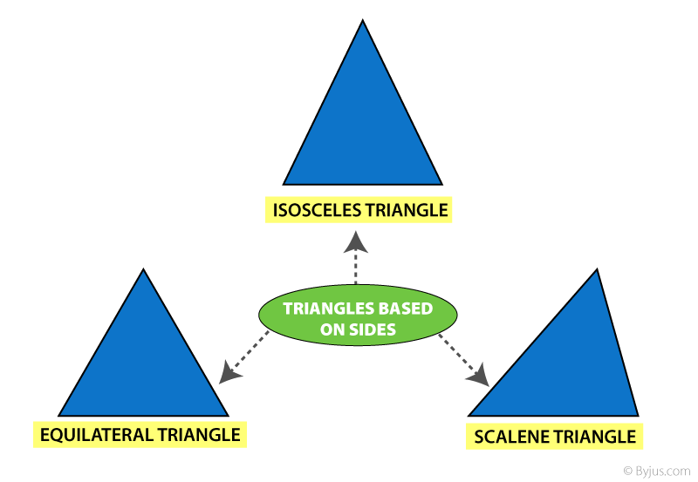
Triangles- Based on Angles
- Acute angled Triangle – Each angle is less than 90°
- Right Angled Triangle – Any one of the three angles equal to 90°
- Obtuse Angled Triangle – Any one angle is greater than 90°
The below figure shows the three types of angles, based on angles.
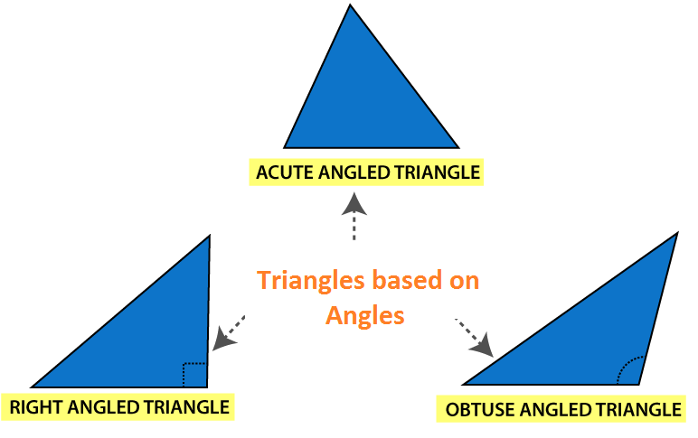
An Activity:
- Draw different triangles of any dimensions using squares and measuring scales.
- Measure the length of the sides and note them down.
- You will observe that the sum of any 2 sides of the triangle is Always Greater than the 3rd side.
Quadrilaterals (4-gon)
A Quadrilateral is a polygon having a number of sides equal to four. That means a polygon is formed by enclosing four line segments such that they meet at each other at corners/vertices to make 4 angles.
Like triangles, a quadrilateral is also classified with different types:
- Square
- Rectangle
- Parallelogram
- Rhombus
- Trapezium
The below figure shows the classification of quadrilaterals.
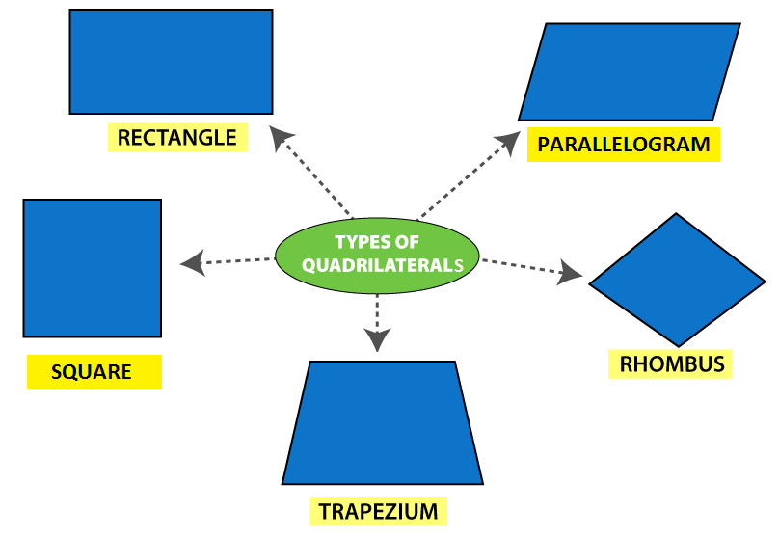
The table below gives the comparison of Opposite sides, angles, and diagonals of different Quadrilaterals.
Quadrilateral | Opposite | Sides | All sides Equal | Opposite angles equal | Diagonal | Diagonal
 | Parallel | Equal |  |  | Equal | Perpendicular
Rectangle | ✔ | ✔ | ✖ | ✔ | ✔ | ✔
Parallelogram | ✔ | ✔ | ✖ | ✔ | ✖ | ✖
Rhombus | ✔ | ✔ | ✔ | ✔ | ✖ | ✔
Trapezium | ✖  (Only one side) | ✖ | ✖ | ✖ | ✖ | ✖
Square | ✔ | ✔ | ✔ | ✔ | ✔ | ✔
Names of Polygon
Polygon | No. of Sides | No. of Diagonal | No. of vertices | Interior Angle
Triangle | 3 | 0 | 3 | 60
Quadrilateral | 4 | 2 | 4 | 90
Pentagon | 5 | 5 | 5 | 108
Hexagon | 6 | 9 | 6 | 120
Heptagon | 7 | 14 | 7 | 128.571
Octagon | 8 | 20 | 8 | 135
Nonagon | 9 | 27 | 9 | 140
Decagon | 10 | 35 | 10 | 144
Hendecagon | 11 | 44 | 11 | 147.273
Dodecagon | 12 | 54 | 12 | 150
Triskaidecagon | 13 | 65 | 13 | 158.308
Tetrakaidecagon | 14 | 77 | 14 | 154.286
Pentadecagon | 15 | 90 | 15 | 156
Three Dimensional Shape (3-D shape)
A three-dimensional shape is a solid object that is formed by a combination of polygons and 2d shapes. Some of the 3d shapes which we can observe in real-life are:
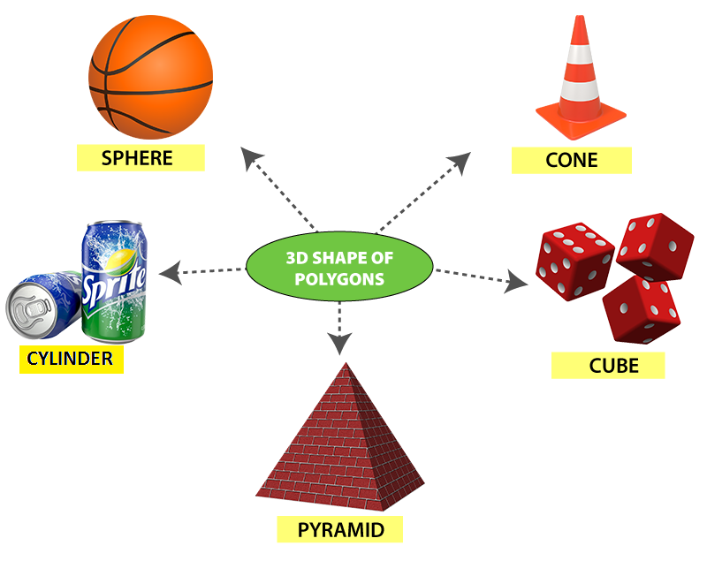
- These are the shapes that can be projected on a piece of paper but cannot be drawn on paper. These shapes are known as solids.
2-D shape (Polygon) | 3-D Shape
Edge | Edge
Vertices | Vertices
— | Faces
- 3-D shapes have faces as the distinguishing feature.
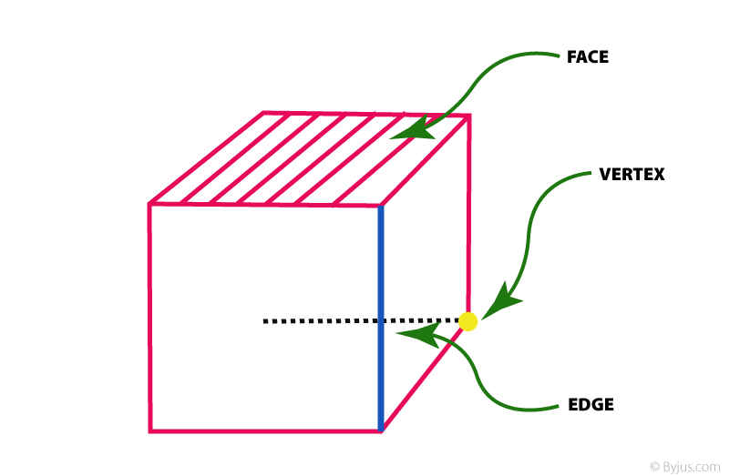
To know more about polygons, types of polygons and 3-D shapes, download BYJU’S – The Learning App.
Frequently Asked Questions – FAQs
Q1
What is a polygon?
A polygon is a closed two-dimensional shape that is formed by enclosing line segments. A minimum of three line segments are required to make a polygon.
Q2
What is called a polygon with 7 sides?
A polygon with 7 sides is called a Heptagon. This polygon has 7 vertices.
Q3
What is called a polygon with 9 sides?
A polygon with 9 sides is known as Nonagon. This polygon has 9 vertices.
Q4
How many diagonals does a polygon have?
If there are n sides in a polygon (or n-sided polygon), then the polygon will have n(n – 3)/2 diagonals. Triangles do not have diagonals.
Q5
What are the different types of polygons?
Polygons are classified mainly into four categories. They are:
Regular polygon – all the sides and measure of interior angles are equal
Irregular polygon – all the sides and measure of interior angles are not equal, i.e. different
Convex polygon – all the interior angles of a polygon are strictly less than 180 degrees. The vertex will point outwards from the centre of the shape
Concave polygon – one or more interior angles of a polygon are more than 180 degrees. A concave polygon can have at least four sides. The vertex points towards the inside of the polygon.

